Playlist for Cloud (AWS) for SDE-III
☁️ CLOUD (AWS) MASTER PLAYLIST — BACKEND ENGINEERS
Cloud is expected knowledge, not optional, for SDE-III.

🟢 PHASE 1 — AWS FUNDAMENTALS (Day 1–6)
Goal: Understand AWS like a system designer, not a beginner
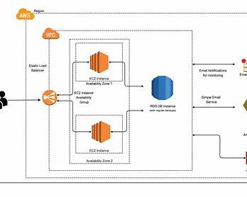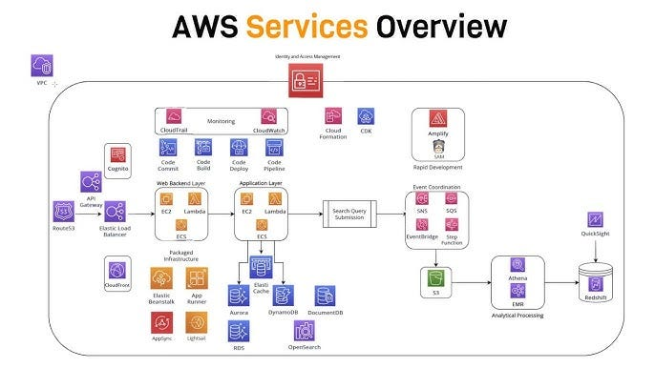
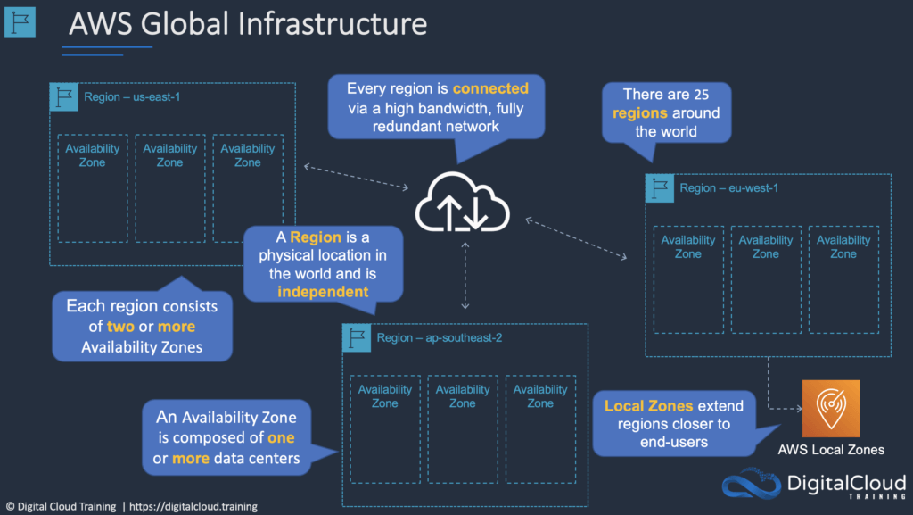

Day 1 — Introduction to Cloud & AWS
▶ What is Cloud Computing
▶ Why companies use Amazon Web Services
▶ Regions, AZs, Edge locations
▶ Shared responsibility model

Day 2 — IAM (VERY IMPORTANT)
▶ Users, Groups, Roles
▶ Policies (Inline vs Managed)
▶ Least privilege principle
▶ IAM in interviews (common mistakes)
📌 Interview Rule:
If you don’t understand IAM → you don’t understand AWS.

Day 3 — EC2 Deep Dive
▶ EC2 lifecycle
▶ Instance types (compute vs memory)
▶ Security Groups vs NACL
▶ SSH best practices
▶ EC2 pricing intuition

Day 4 — VPC Basics (Must for Interviews)
▶ What is VPC
▶ Public vs Private subnet
▶ Internet Gateway
▶ NAT Gateway
▶ Route tables (simple explanation)

Day 5 — S3 (Object Storage)
▶ Buckets & objects
▶ S3 vs EBS vs EFS
▶ Versioning
▶ Lifecycle policies
▶ Security (bucket policies)

Day 6 — Load Balancer + Auto Scaling
▶ ALB vs NLB
▶ Target groups
▶ Health checks
▶ Auto Scaling Groups
▶ How traffic flows (diagram-based)

🔵 PHASE 2 — DATABASE & SERVERLESS (Day 7–11)
Goal: Data + compute choices
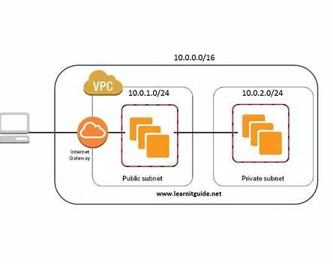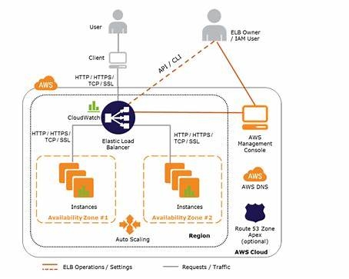

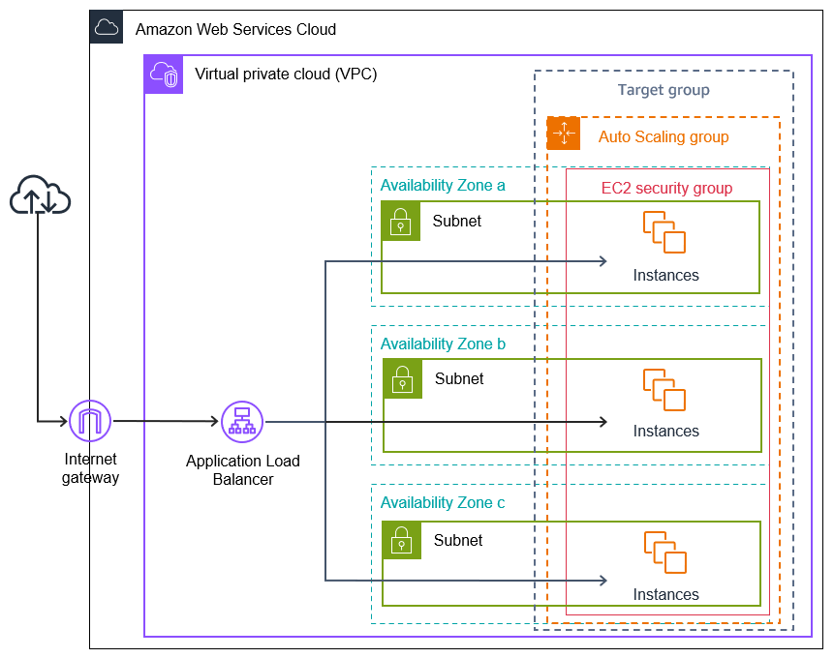

Day 7 — RDS (MySQL/Postgres)
▶ RDS architecture
▶ Multi-AZ
▶ Read replicas
▶ Backups & snapshots
▶ Connection pooling problem

Day 8 — DynamoDB (Optional but Powerful)
▶ When NOT to use RDS
▶ Partition key & sort key
▶ Strong vs eventual consistency
▶ DynamoDB interview scenarios

Day 9 — Lambda (Serverless)
▶ What is Lambda
▶ Cold start problem
▶ Lambda vs EC2
▶ Real backend use cases

Day 10 — API Gateway
▶ API Gateway + Lambda
▶ Auth at API Gateway
▶ Throttling & rate limits
▶ Backend-for-Frontend pattern

Day 11 — CloudWatch
▶ Logs
▶ Metrics
▶ Alarms
▶ Monitoring backend services in production

🟣 PHASE 3 — DEPLOY MICROSERVICES ON AWS (Day 12–20)
Goal: Real production deployment
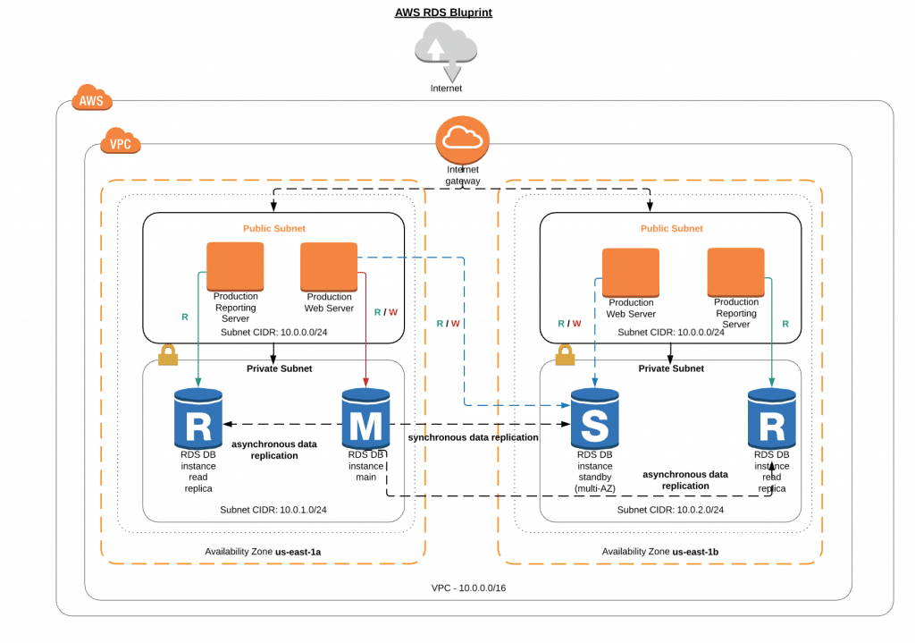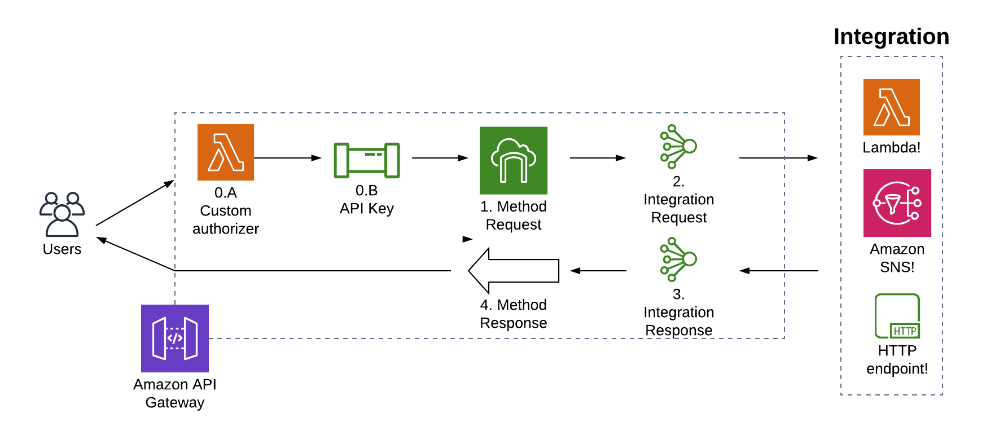
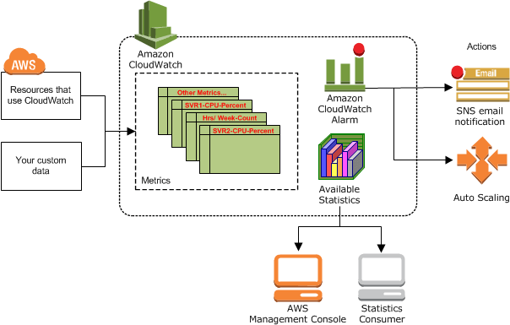

Day 12 — Backend Deployment Strategy
▶ EC2 vs ECS vs EKS (decision guide)
▶ Single service → multi service thinking

Day 13 — Deploy Spring Boot on EC2
▶ EC2 setup
▶ Java install
▶ App deployment
▶ Security group config

Day 14 — RDS Integration
▶ Connect Spring Boot to RDS
▶ Secrets handling
▶ DB security best practices

Day 15 — S3 for File Storage
▶ Upload/download from backend
▶ Presigned URLs
▶ Secure access patterns

Day 16 — ECR (Docker Registry)
▶ Push images to ECR
▶ IAM permissions
▶ Image versioning

Day 17 — ECS Basics
▶ ECS cluster
▶ Task definition
▶ Service
▶ Load balancer integration

Day 18 — ECS with Microservices
▶ Run User / Product / Order services
▶ Service-to-service communication

Day 19 — API Gateway in Front
▶ Route requests
▶ Auth at gateway
▶ Centralized throttling

Day 20 — End-to-End AWS Architecture
▶ Client → API Gateway → ECS → RDS
▶ Failure points
▶ Scaling strategy

🟠 PHASE 4 — MESSAGING & EVENTING (Day 21–23)
Goal: Async cloud systems
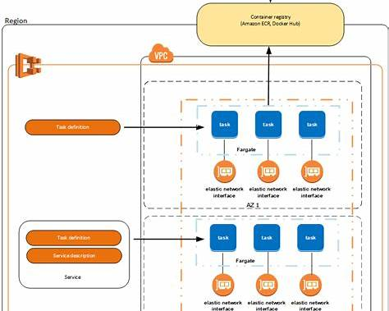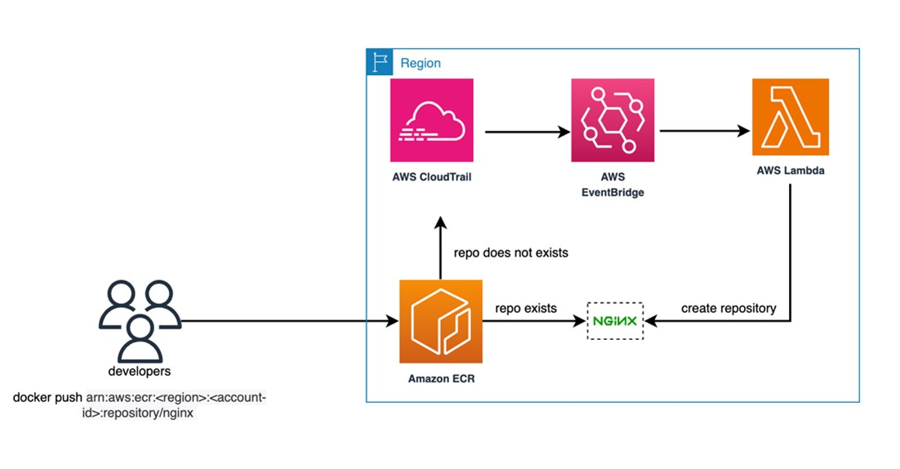

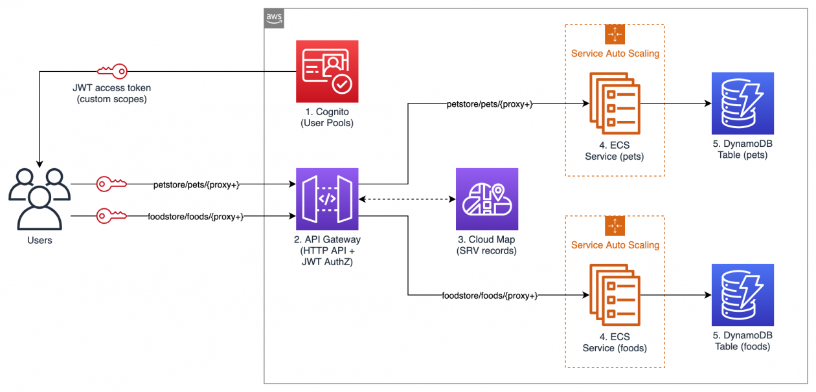

Day 21 — SNS & SQS
▶ Pub/Sub vs Queue
▶ Order → Payment use case
▶ DLQ (Dead Letter Queue)

Day 22 — Event-Driven Architecture on AWS
▶ SQS vs Kafka vs SNS
▶ When AWS native is enough
▶ Cost vs control trade-offs

Day 23 — Reliability Patterns in AWS
▶ Retries
▶ Idempotency
▶ Rate limiting
▶ Backpressure

🔴 PHASE 5 — CI/CD PIPELINE (Day 24–27)
Goal: Production-ready DevOps mindset
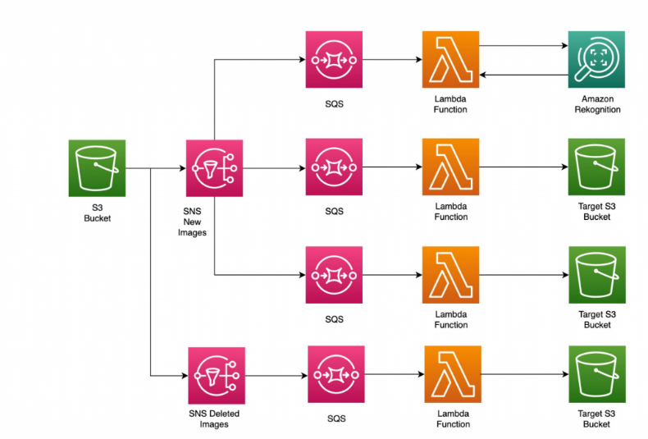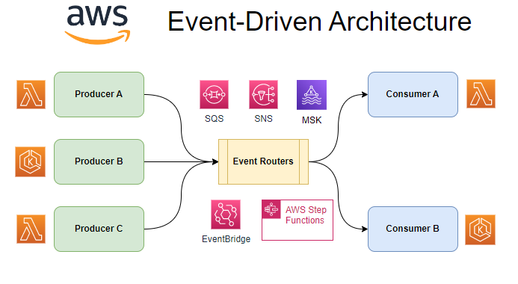

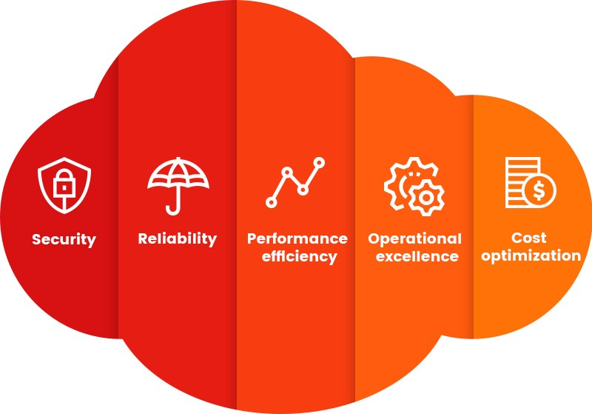

Day 24 — CI/CD Basics for Backend Engineers
▶ Why CI/CD matters
▶ GitHub Actions overview

Day 25 — Build CI Pipeline
▶ Code → build → test
▶ Docker image build
▶ Push to ECR

Day 26 — Deploy via CI/CD
▶ GitHub Actions → ECS
▶ Zero-downtime deployment

Day 27 — EKS (Optional Advanced)
▶ When companies expect EKS
▶ ECS vs EKS comparison
▶ High-level EKS flow

🟢 PHASE 6 — INTERVIEW & SYSTEM DESIGN MAPPING (Day 28–30)
Goal: Convert cloud knowledge → interview answers

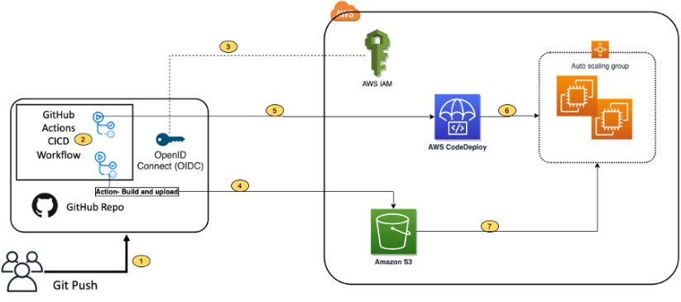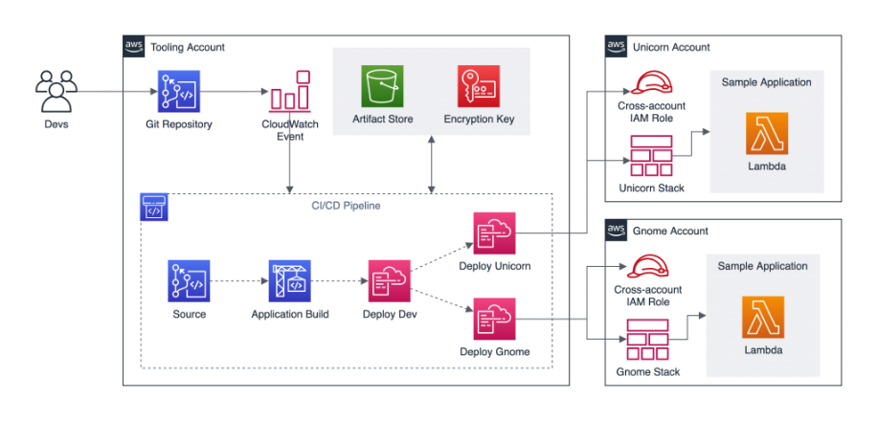

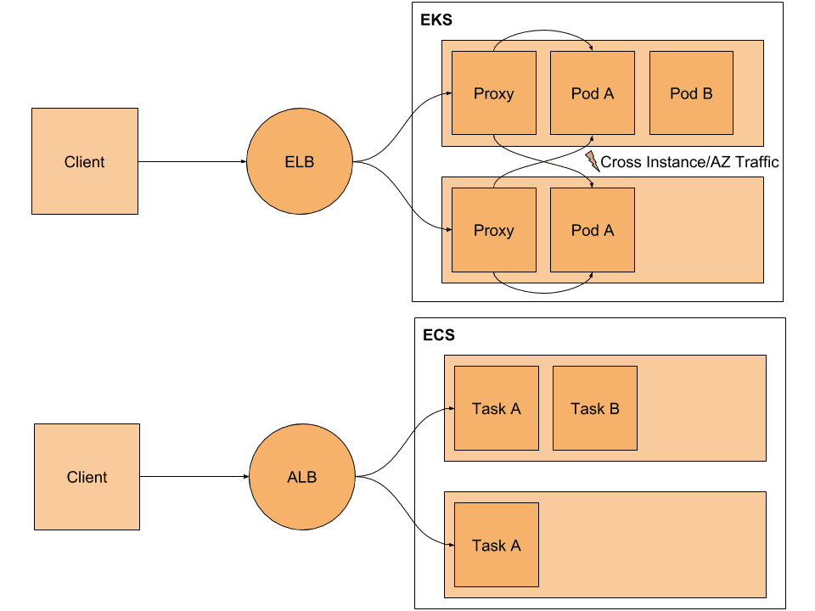

Day 28 — AWS Interview Questions (Backend)
▶ EC2 vs Lambda
▶ RDS vs DynamoDB
▶ S3 vs EBS
▶ ALB vs NLB

Day 29 — Cloud in System Design
▶ How AWS fits in system design rounds
▶ Mapping services to design components

Day 30 — Final Cloud Architecture Project
▶ Design & explain:
- User Service
- Order Service
- Payment Service
- API Gateway
- RDS + S3
- ECS + Load Balancer
▶ How to explain this in interviews
▶ Resume & project discussion tips

